MMS : End User & Warehouse Admin Changes
(Login changes & User Management)
Sections
- Login
- User Management (warehouse admins)
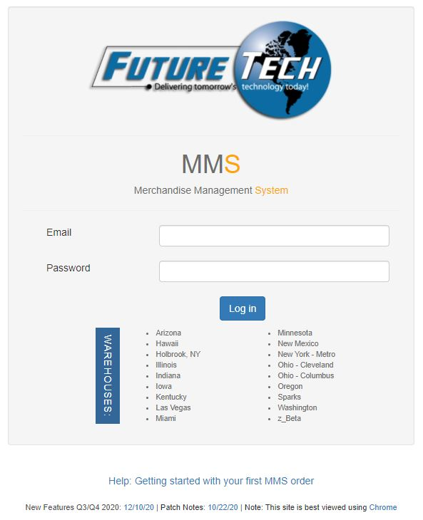
Login Changes
The login page now houses just 1 login panel. We consolidated SQL and AD accounts into one. Moving forward, users will use their email address as their username and their Active Directory password. In some rare cases, users might be setup to bypass Active Directory with a manually setup password.
These accounts (sales and warehouse admins) now have the ability to have access to more than 1 location (if necessary). Upon logging in, if a user has rights to 1 warehouse, they will automatically login to that warehouse. However, if they have access to more than 1, they will now land on a list showing which warehouses they can enter - with some permissions exposed. (sample shot below is my personal account with access to many warehouses)
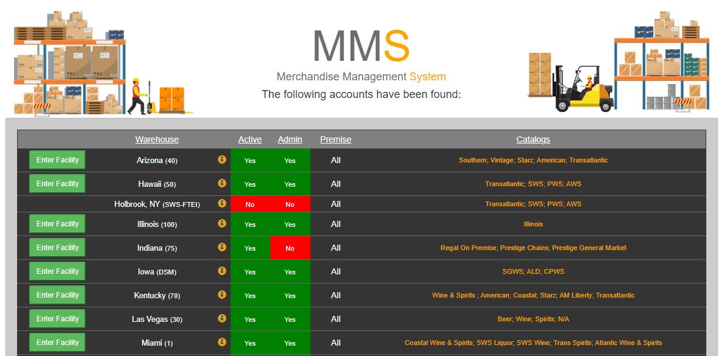
From this list the user chooses which warehouse they would like to continue into. Inactive status on a warehouse will block your access to login there. (as shown on the 3rd item above) Once you enter, everything works the same as it always had.

User Management within MMS (warehouse administrators)

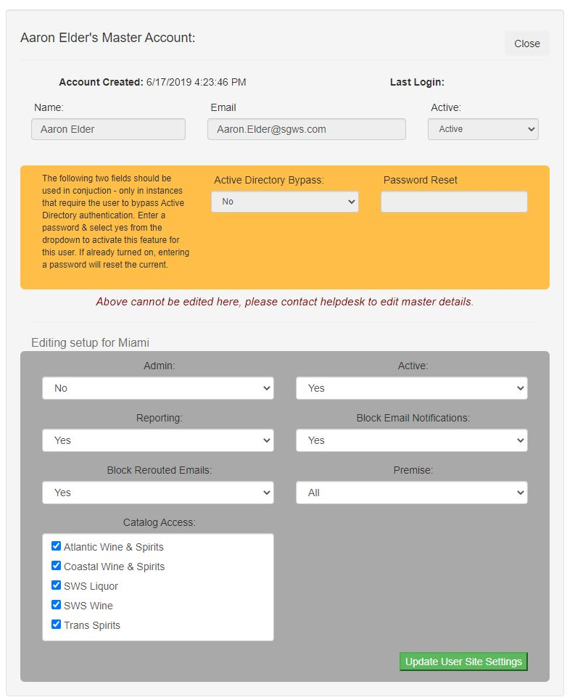
Warehouse administrators have access to manage users within their own warehouse. However, they are limited to altering the permissions for that user within that warehouse. They cannot modify anything from the master account (name, AD bypass, etc). Nor can they create a user, but they can have a user login to automatically create their parent account. After doing so, it would give warehouse admins access to add them to the warehouse without the need for helpdesk intervention. Few things to note. The Filter By dropdown list is now only used to filter by Approver groups. All other filtering for this list can be handled in the header of the grid list. You can use header filters on the main list for name, email, active, admin flag and premise. Simply click the green edit button to jump into the details of that specific user. (As shown below)
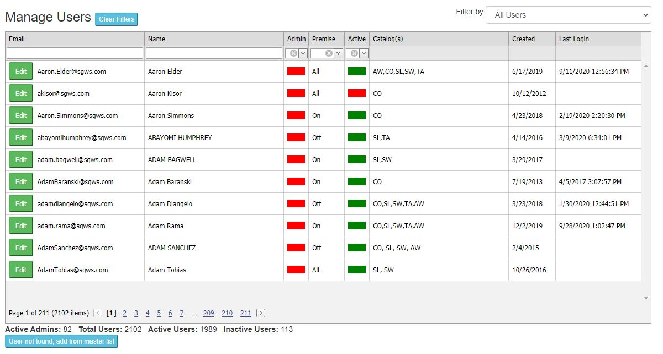

From here, you will enter the users main detail page where you can adjust their permissions for this specific warehouse only. Be sure to hit the “Update User Site Settings” button upon completion.

